**OUTPUT - Problem 1:**

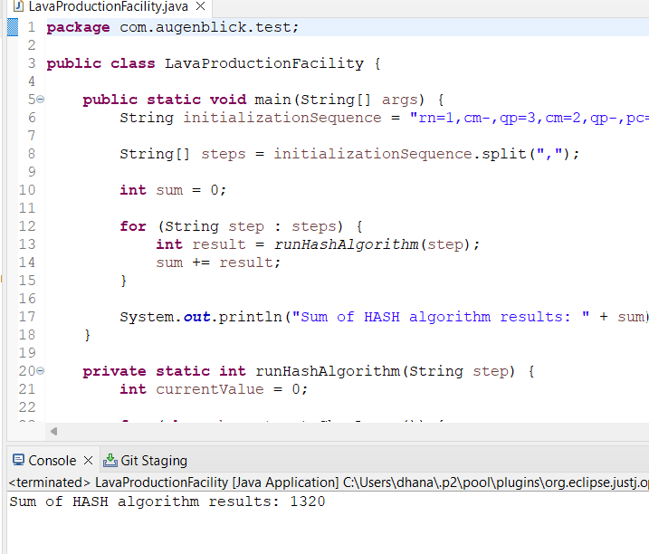

**OUTPUT – Problem 2:**

